**TERRAFORM PRACTICAL SESSION**

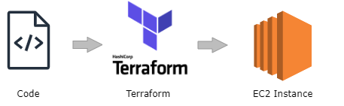

**TASK:**

* Write Terraform code to create 10 EC2 instances.

**ALGORITHM** (To Setup AWS CLI & Terraform)

* **Step1:** Create IAM user with Administrator access & generate access key & secret key
* **Step2:** Open command prompt/ Visual Studio. Copy AWS CLI package command for Windows & run it. This will download & install AWS CLI in your local machine.

Download link (AWS CLI): msiexec.exe /i <https://awscli.amazonaws.com/AWSCLIV2.msi>

Reference: <https://docs.aws.amazon.com/cli/latest/userguide/getting-started-install.html>

* **Step3:** Download Terraform for Windows, unzip & store it in “C:\Terraform” folder
* **Step4:** Set system environment variables for Terraform

Edit system environment variables 🡪 Environment Variables 🡪 System variables: Path (double-click) 🡪 New 🡪 “C:\Terraform” 🡪 OK (3 times). Your system is now ready to run AWS CLI & Terraform commands.

**ALGORITHM** (To run Terraform commands)

* **Step1:** Open Visual studio & create a file “terraform.tf” & open terminal
* **Step2**: Define AWS version (in terraform.tf file)
* **Step3:** Define AWS region (in terraform.tf file)
* **Step4:** Write command to create EC2 instances. (in terraform.tf file)
* **Step5:** Run “terraform init” & “terraform apply” in terminal to initialize & create the infrastructure.

**Command to create EC2 instances**:

**#STEP1: DEFINE AWS VERSION**

**terraform {**

**required_providers {**

**aws = {**

**source = "hashicorp/aws"**

**version = "~>4.0"**

**}**

**}**

**}**

**#STEP2: DEFINE AWS REGION**

**provider "aws" {**

**region = "ap-south-1"**

**}**

**#STEP3: CREATE EC2 INSTANCE**

**resource "aws_instance" "server" {**

**ami = "ami-0607784b46cbe5816"**

**instance_type = "t2.micro"**

**count = 10**

**tags = {**

**Name = "MyServer"**

**}**

**}**

**Terraform Commands**:

**terraform init**: to initialize terraform.

**terraform plan**: it will show what changes will be made.

**terraform apply**: to apply & create the infrastructure.

**terraform destroy**: to destroy the created infrastructure.